***Problem 2***

***The dataset Education - Post 12th Standard.csv is a dataset that contains the names of various colleges. This particular case study is based on various parameters of various institutions. You are expected to do Principal Component Analysis for this case study according to the instructions given in the following rubric. The data dictionary of the 'Education - Post 12th Standard.csv' can be found in the following file: Data Dictionary.xlsx.***

**2.1) Perform Exploratory Data Analysis [both univariate and multivariate analysis to be performed]. The inferences drawn from this should be properly documented.**

The dataset has (777, 18) Rows and Columns

It has 18 Columns, Names column is of type Object we can remove this for Analysis.

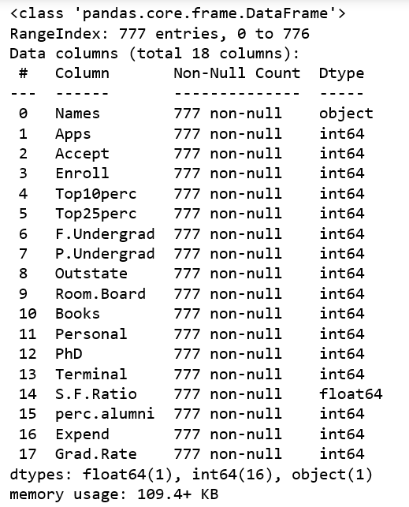

No Null Values

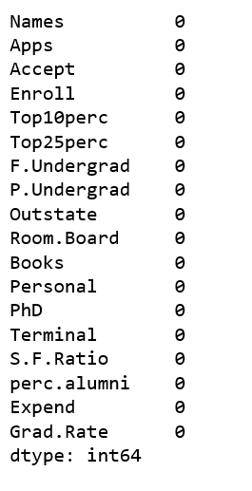

Check for Outlier:

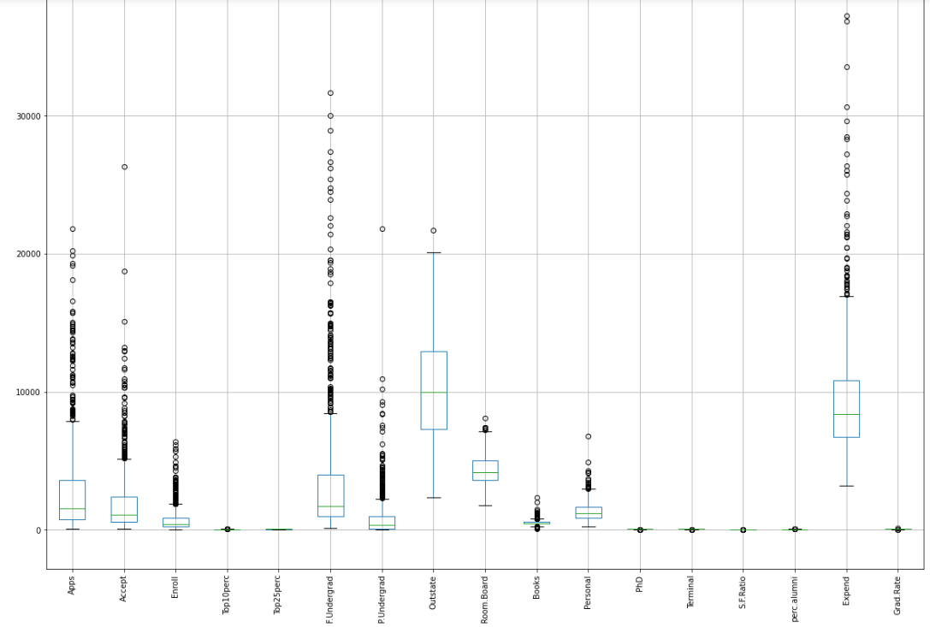

Almost Every variable has outliers.

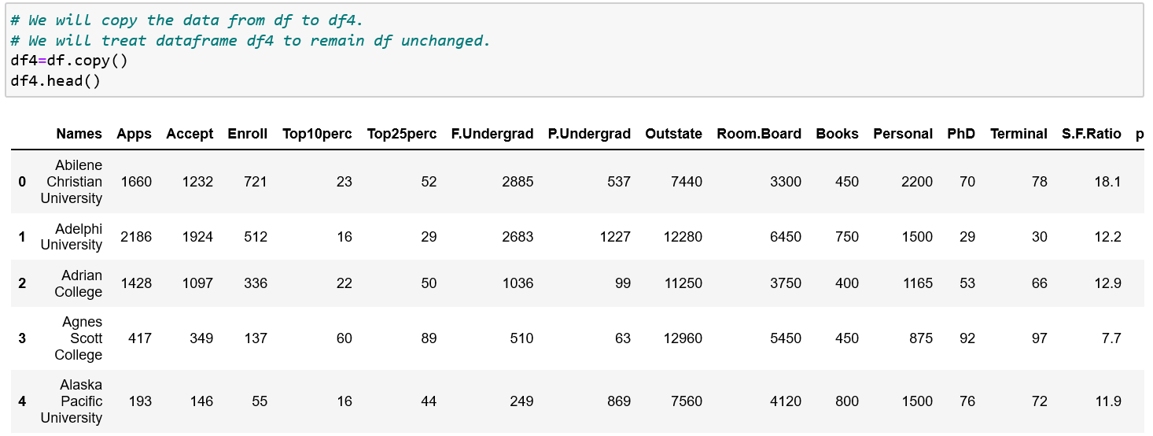

We will Define function to Remove Outliers, In this we are calculating Q1,Q3,Inter Quartile range

This function is Returning lower_range and Upper range values.

Outlier Treatment by using user defined Function "remove_outlier".

In lrapps we are saving result of lower range and in urapps we are saving result of upper range

After Treatment The boxplot will look like

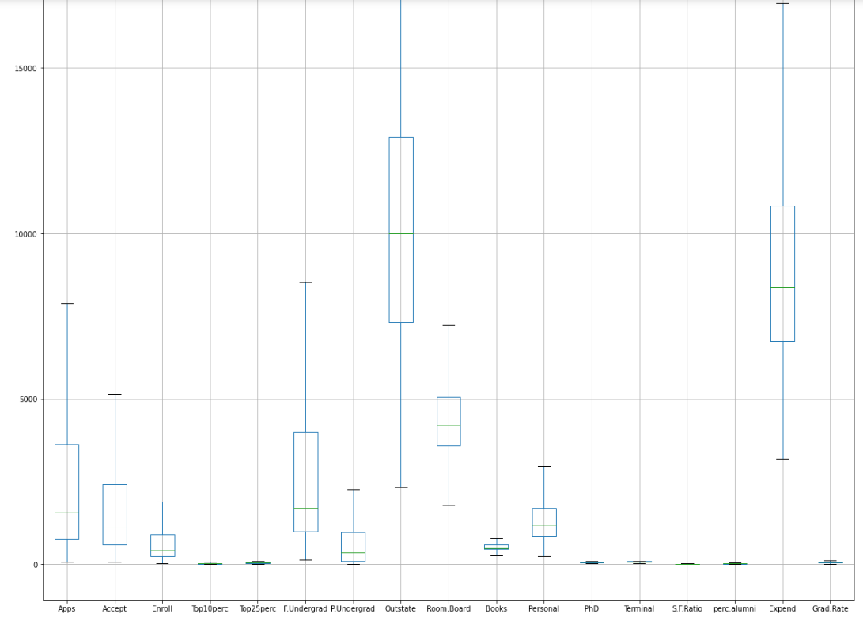

***2.1) Perform Exploratory Data Analysis [both univariate and multivariate analysis to be performed]. The inferences drawn from this should be properly documented.***

Lets plot a distplot to see how the data is distributed.

Creating Univariate Distribution plot to analyse each variable thouroughly, we will get outliers then

Shape of plot, How is the distribution.

by plotting pairplot,Heatmap we can see correlation between two different variables.

We will get the initial idea of distribution here.

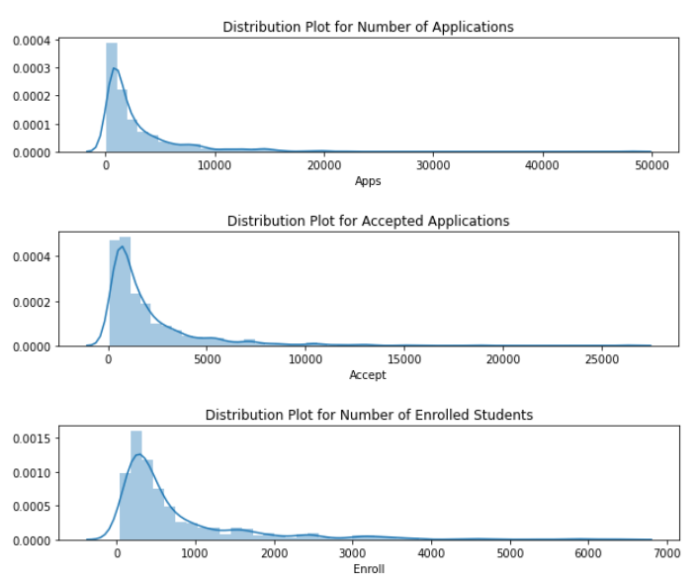

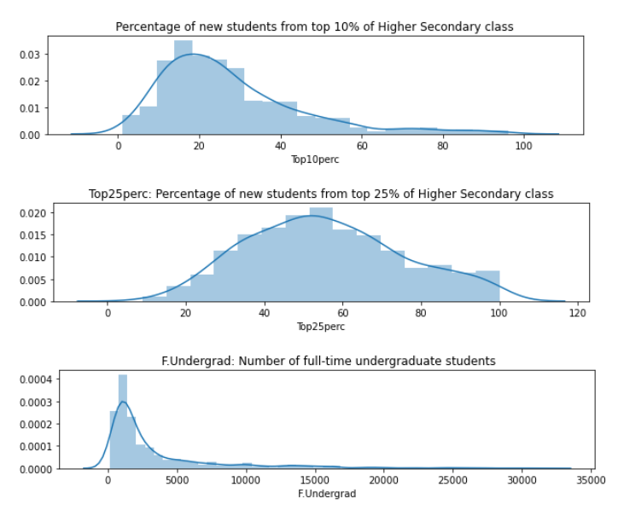

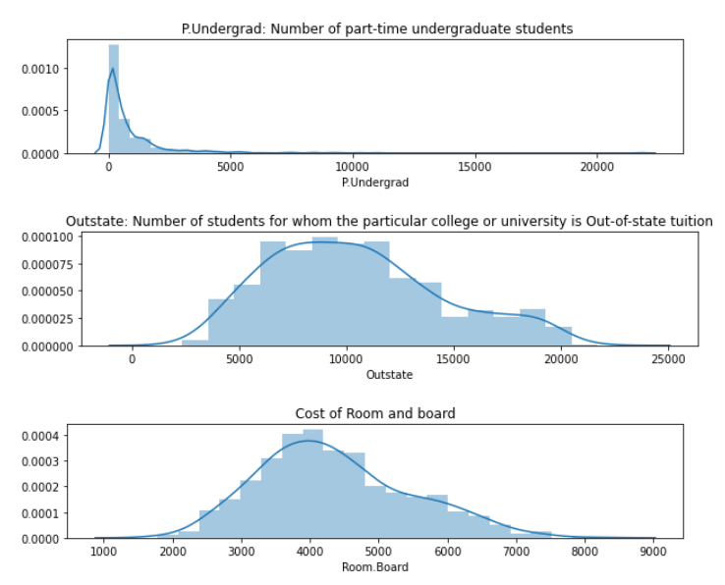

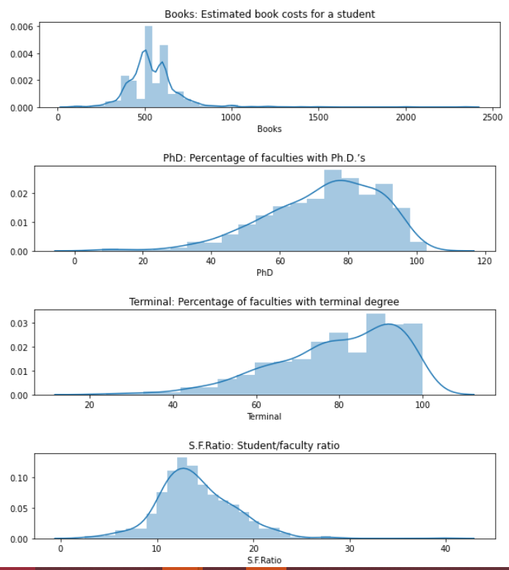

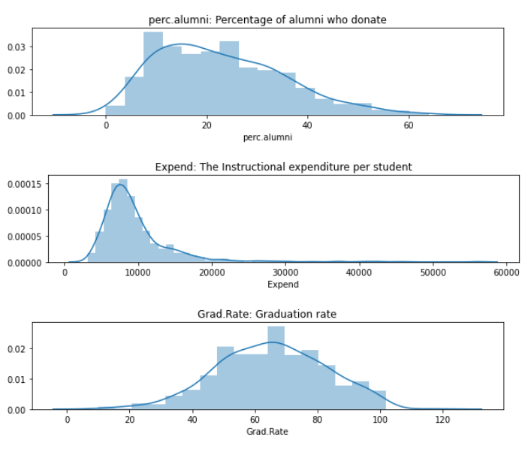

***Creating Bivariate Distribution plot***

*Plot Pairplot*

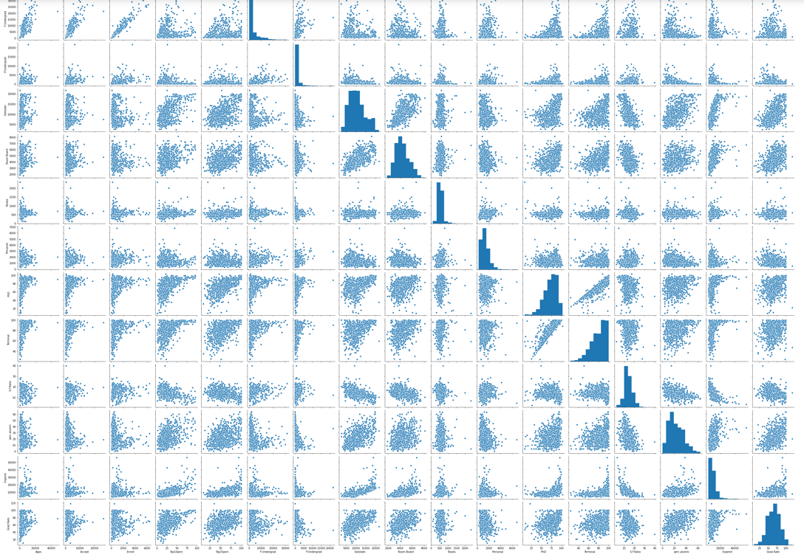

*Plot Heatmap, to see Correlation between variables Lets plot correlation Heatmap to get better visualization of behaviour of Multiple variables amongst each other*

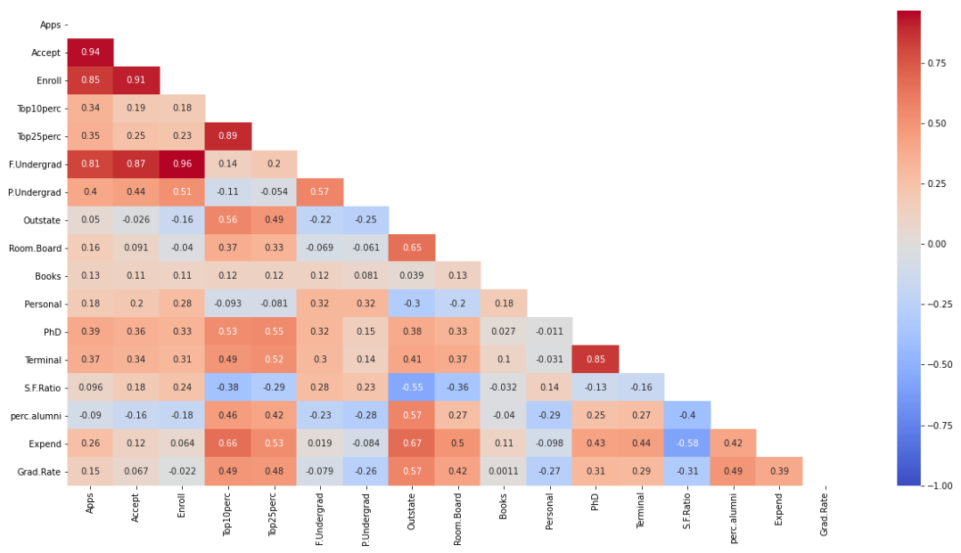

We can group all the distributions into Left Skewed,Right Skewed and Normal Distribution as follows by looking at Distribution plots.

-->Left Skewed: Personal  
PhD  
Terminal

--> Right Skewed: Apps  
Accept  
Enroll  
Top10perc  
F.Undergrad  
P.Undergrad  
Books  
Expend  
S.F.Ratio

-->Normal Distribution Top25perc  
Outstate  
Room.Board  
perc.alumni  
Grad.Rate

Some Insights that can be drawn from Above Heatmap.

-->From the above heatmap,we can see Strong Positive Correlation between Acceptance and Number of Applications,Enrollment and No of Applications,No.of Full time Under graduates and No of Applications,

-->Enrollment and No of Acceptance,No.of Full time Under graduates and No of Acceptance, No.of part time Under graduates and No of Acceptance, Acceptance is directly proportional to PhD candidates.

-->It seems Obvious that Student to Faculty ratio is inversely related to Instructional Expenditure, Expenditure is increasing when S/F ratio is decreased

-->If top 10% students and top 25% students count is High in college it seems that Graduation Rate is High, PhD rate is High. It is possible that These top students might end up by doing PhD It is interesting if we deeper dive into relation of These students with PhD graduates.

-->Due to higher percentage of outstate student, Cost of Room and boarding is also High or vice versa.

-->College having Faculties with terminal degrees, seems to have higher Instructional expenditure of students

-->Outstate students scored higher percentage in case of top 10 percent and 25 percent students

##### *2.2) Scale the variables and write the inference for using the type of scaling function for this case study.*

##### 

**Often the variables of the data set are of different scales i.e. one variable is in Currency and other is Headcount. in our data set Room and Boarding Fees is having values in thousands and Top 10 percent,25 Percent just two digits. Since the data in these variables are of different scales, it is tough to compare these variables.**

**Feature scaling (also known as data normalization) is the method used to standardize the range of features of data. Since, the range of values of data may vary widely, it becomes a necessary step in data preprocessing to draw some fruitful Insights.**

**In this method, we convert variables with different scales of measurements into a single scale.**

**StandardScaler function normalizes the data using the formula (x-mean)/standard deviation.**

**We will be doing this only for the numerical variables and there are 17 numerical variables and one is nominal variable**

StandardScaler() function Scales the data. and it is taken from sklearn.preprocessing library, Essentially returns the z-scores of every attribute

Scaling all the 17 variables

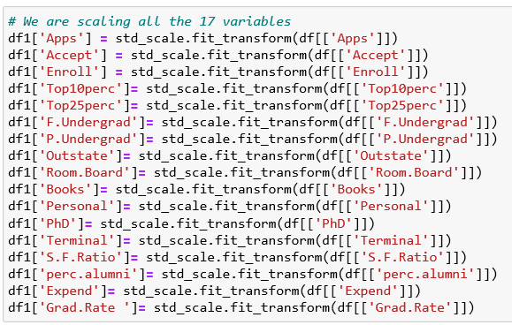

We will find all the Scaled values in dataframe 1, That is df1

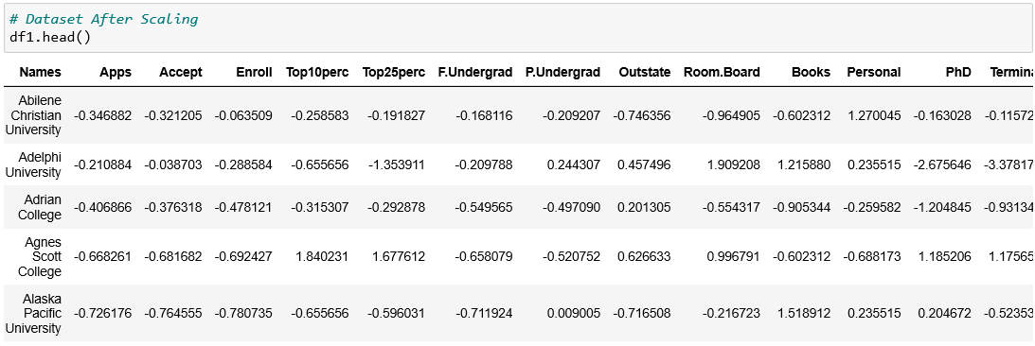

Plot After Scaling,Creating Univariate Distribution plot

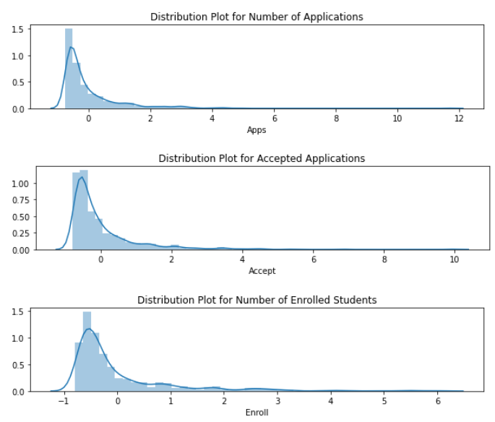

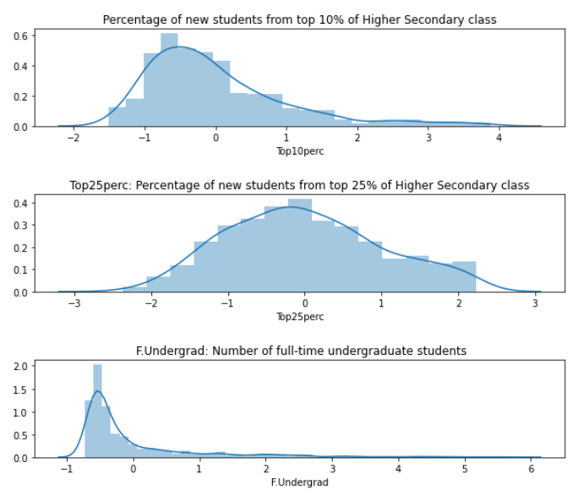

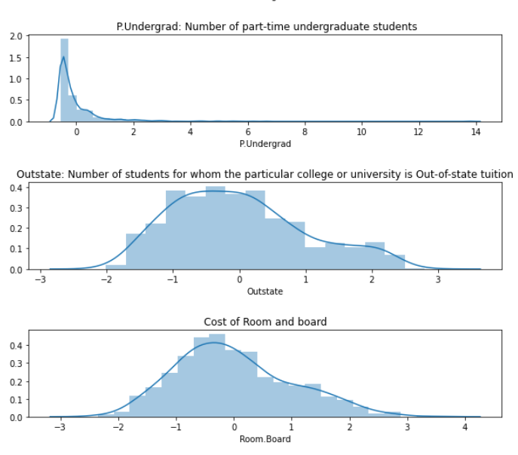

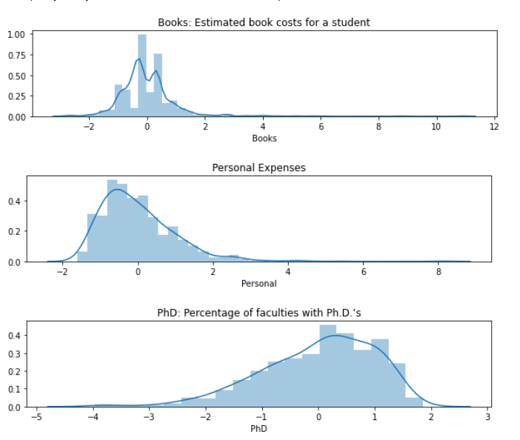

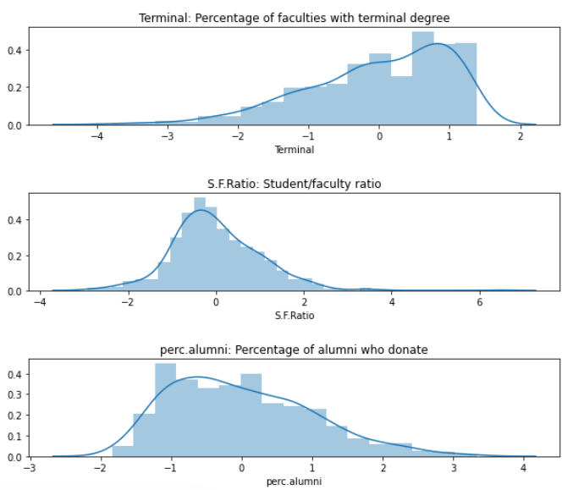

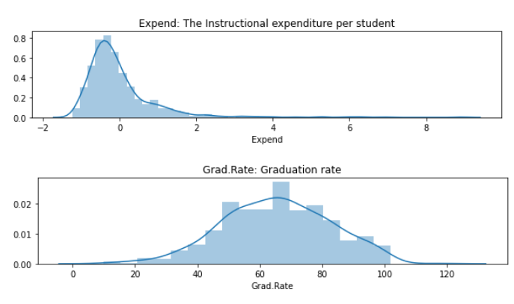

So from Above Graphs we can make Inferences, And we can divide variables into Three Category as similar after Scaling.

Distributon is Right Skew: Apps Accept  
Enroll  
Top10perc  
F.Undergrad  
P.Undergrad  
Books  
Expend  
S.F.Ratio

Distributon is Left Skew: Personal  
PhD  
Terminal

Distributon is Normal: Top25perc  
Outstate  
Room.Board perc.alumni  
Grad.Rate

-->We can see the Distribution is same before and after the Scaling. Scaling only changes scale, by calculating Z scores, The shape of graph will remain same.

-->The skewed data needs Outlier Remove treatment. that we will do in subsequent steps.

-->Still we have not done Outlier treatment, There are High number of Outliers that Resulted into Skewness in plots.We will do outlier treatment in next steps.

***2.3) Comment on the comparison between covariance and the correlation matrix.***

*Plot Correlation matrix (dataframe df, Where Outlier treatment is not done)*

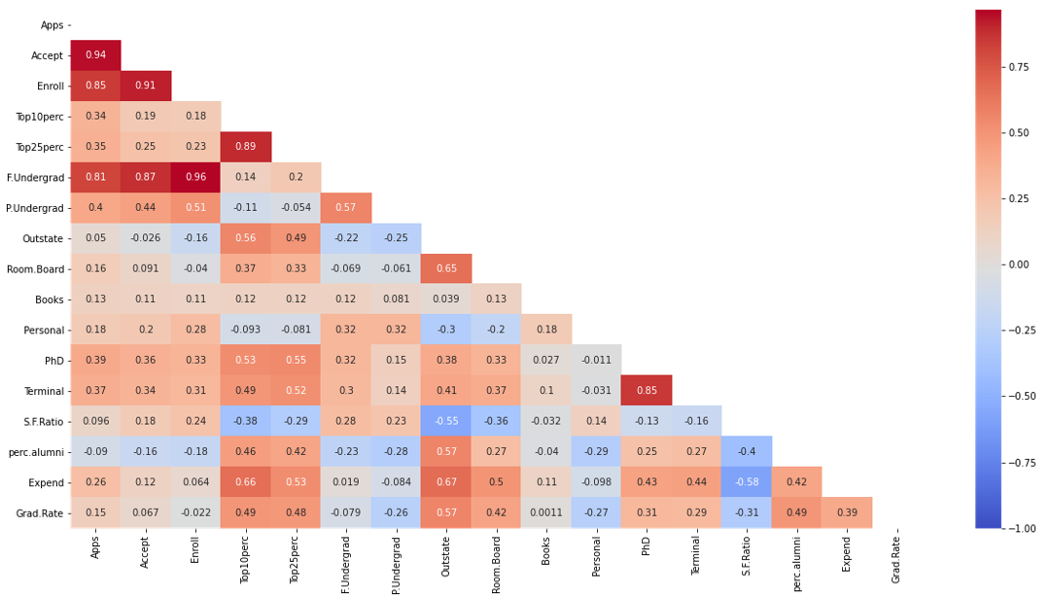

*Plot Correlation matrix, Correlation matrix for Data Without Outliers(Outlier treatment is done on DataFrame df4)*

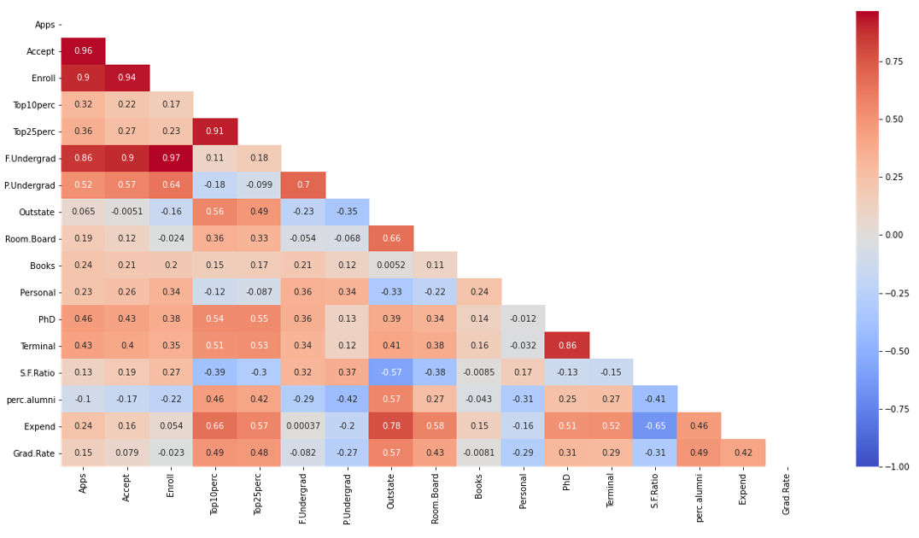

Plot Covarience matrix (dataframe df, Where Outlier treatment is not done)

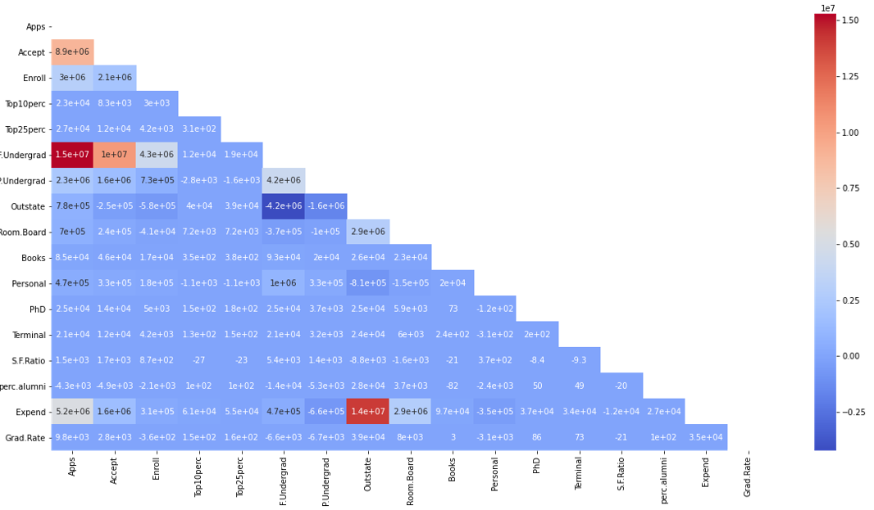

Plot Covarience matrix,Covarience matrix for Data Without Outliers

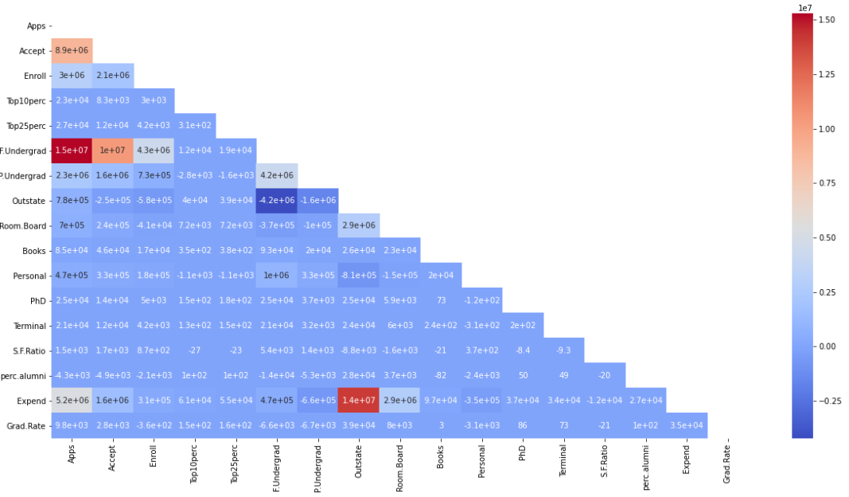

If we Comapare Two Correlation matrix, One with Outliers and other without outliers, We can say that these both Correlation matrix have little changes and are almost equivalent.

Same goes with Covariance Matrix,One with Outliers and other without outliers, We can say that these both covariance matrix have no changes and are equivalent.

Covarience tells us, is there any dependence between two variables,metrics such as "To what extent variables change together". It does not tell us about dependency between variables.

while Correlation gives us Strength and Direction as well. That is One variable is Increasing then other is Increasing or decreasing.additionally it tell us the strength of bond between two variables.

Covariance and Correlation have same analogy as Variance and Std deviation. We have to divide Co-variance by Std deviation,then we get Correlation.

***2.4) Check the dataset for outliers before and after scaling. Draw your inferences from this exercise.***

We will Approach this Question by two plots, One is distribution plot (to see the distriution before and after scaling) and Boxplot(Which will give us idea about outliers)

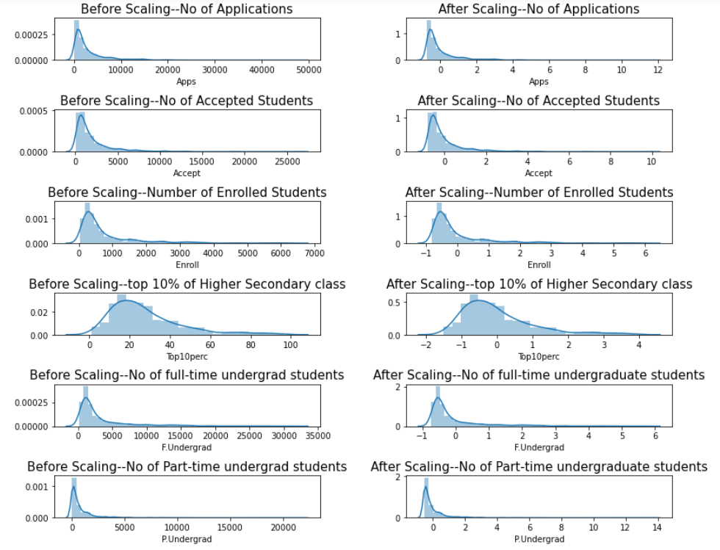

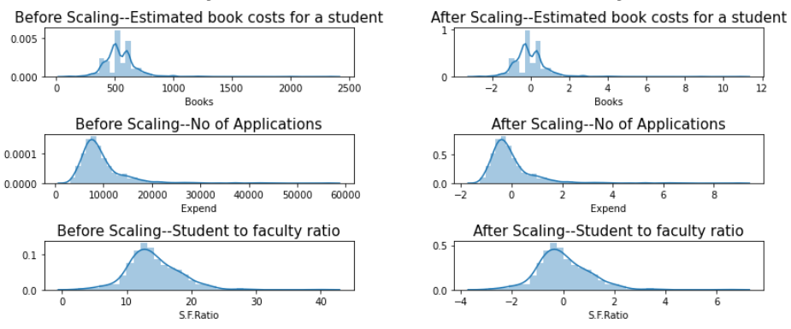

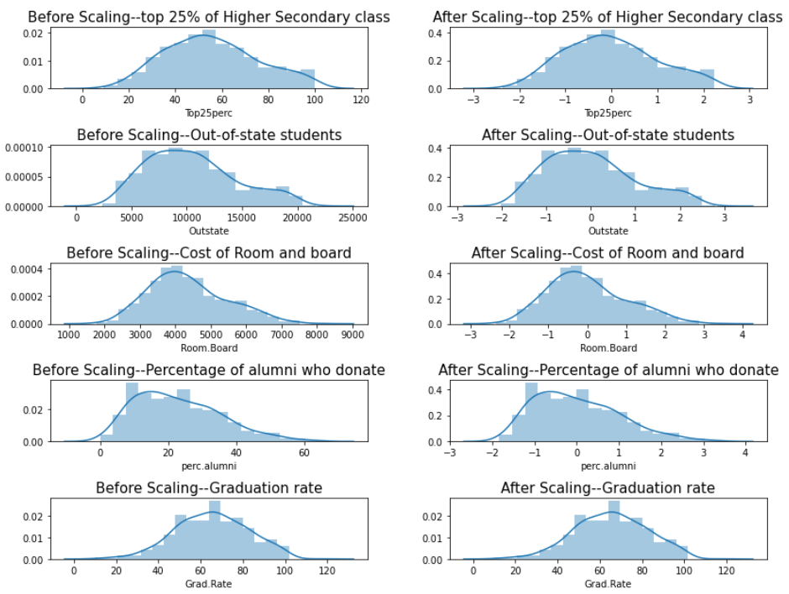

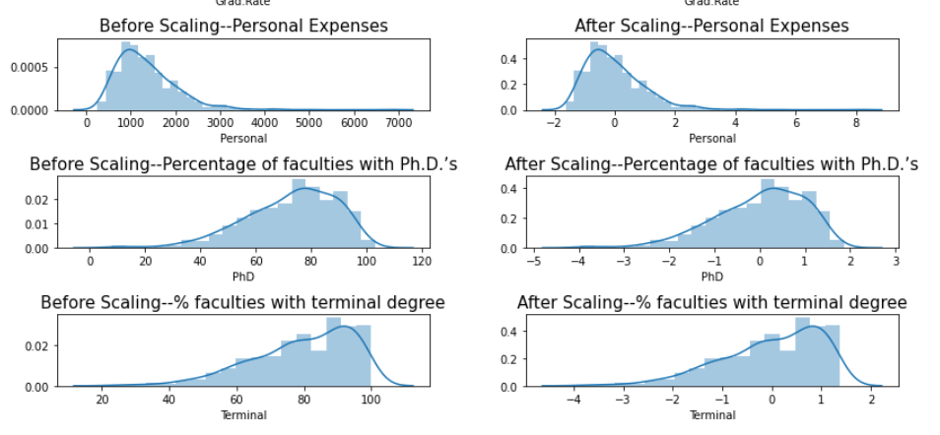

Boxplots:

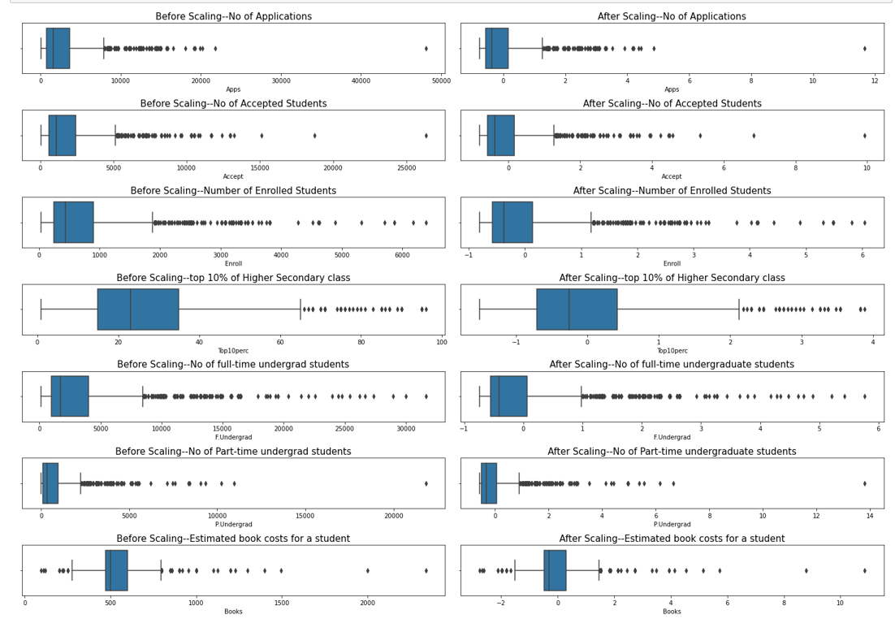

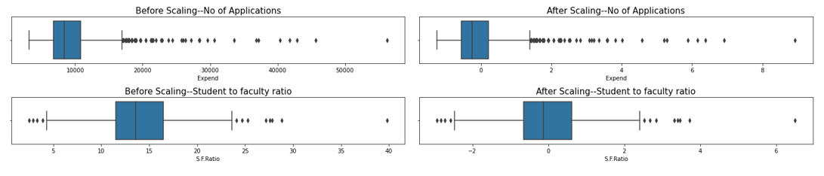

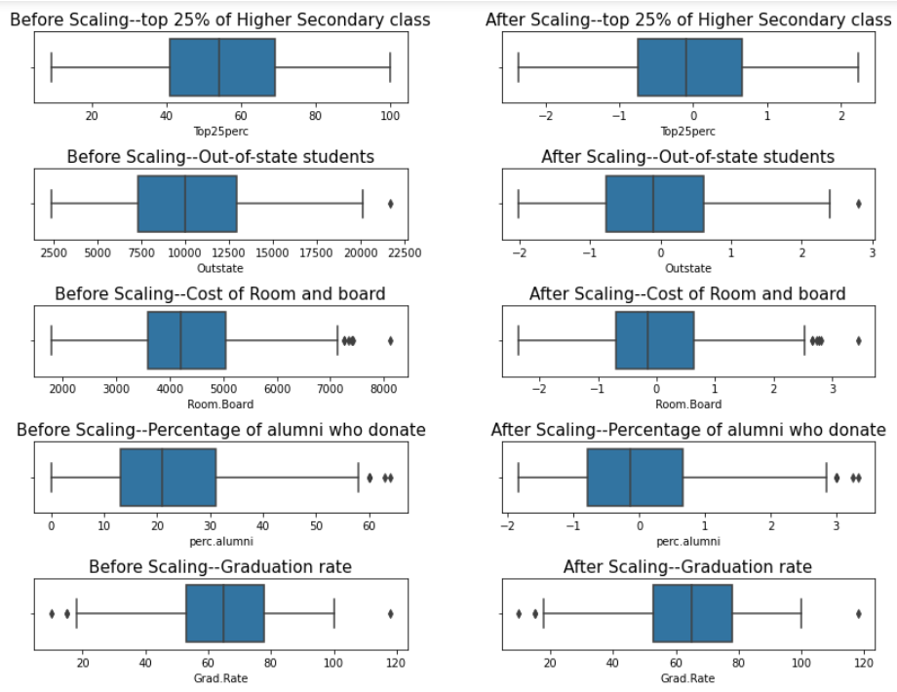

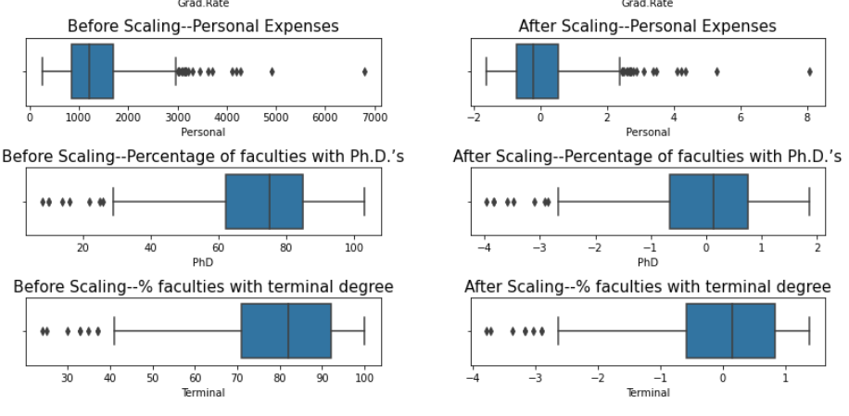

###### So, as you can see the after scaling also, the outliers remain outliers. Only the range is changed.

###### By scaling your variables, you can help compare different variables on equal footing.

###### Scaling will change the range only, and in all the cases outliers will remain outliers after normalisation.

###### All distplot are also same, Note :we are just scaling variables not Normalizing. Hence shape will be same after and before Scaling.

***2.5) Build the covariance matrix, eigenvalues, and eigenvector.***

*We will first take copy of original data and remove column Names, as it has String value not continous numerical values*

*Remove Names Column and Copy it to New dataframe.No changes in df and df1*

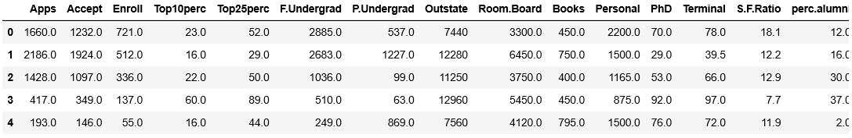

All variables must be on same scale.hence will do Standardization

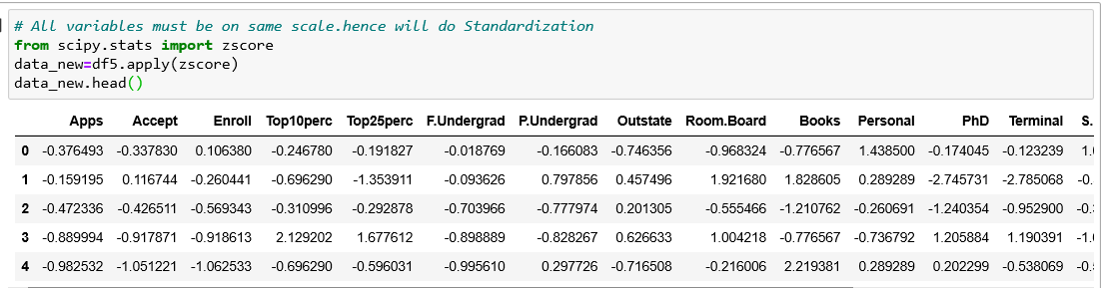

Plot Boxplot to check data has no outliers

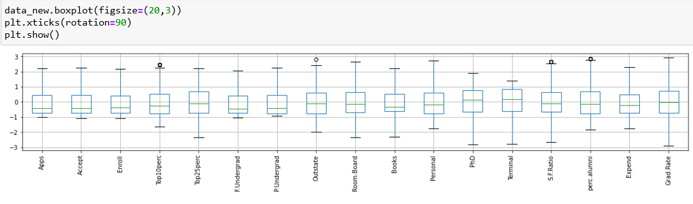

**Step 1: PCA**-***Covariance matrix***

*Np.cov will give us covariance*

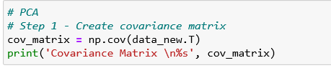

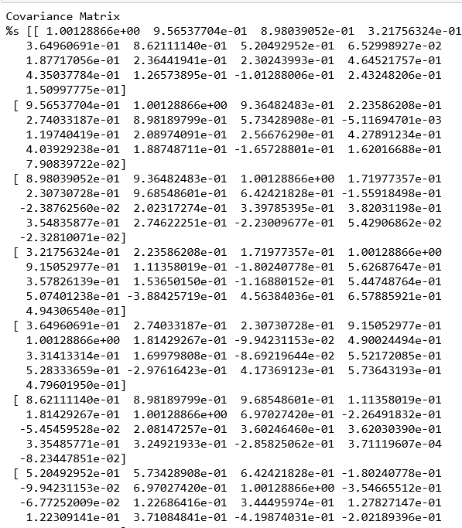

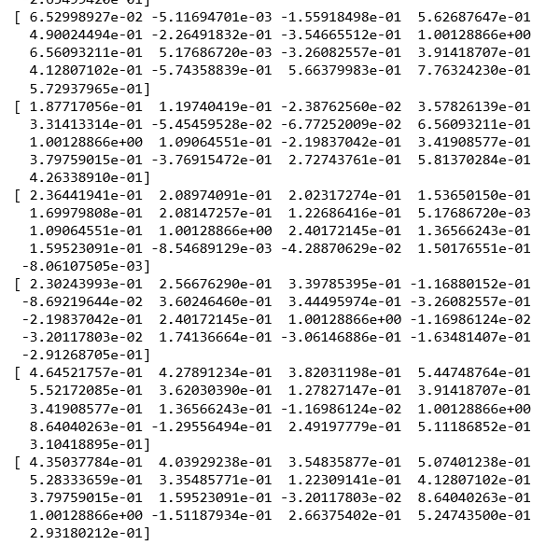

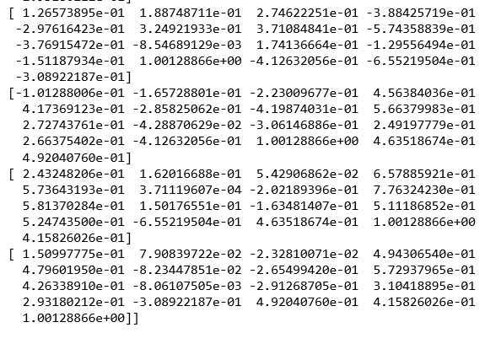

***Step 2: Eigen Values and Eigen Vectors***

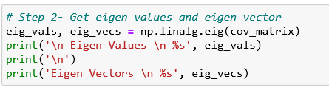

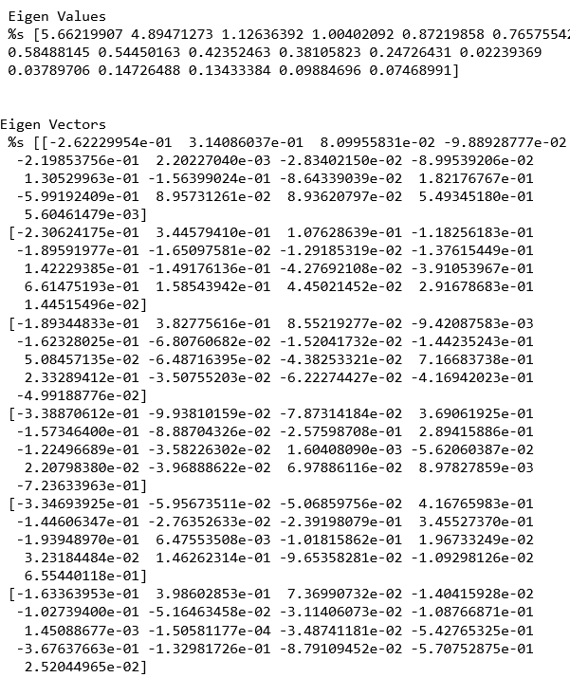

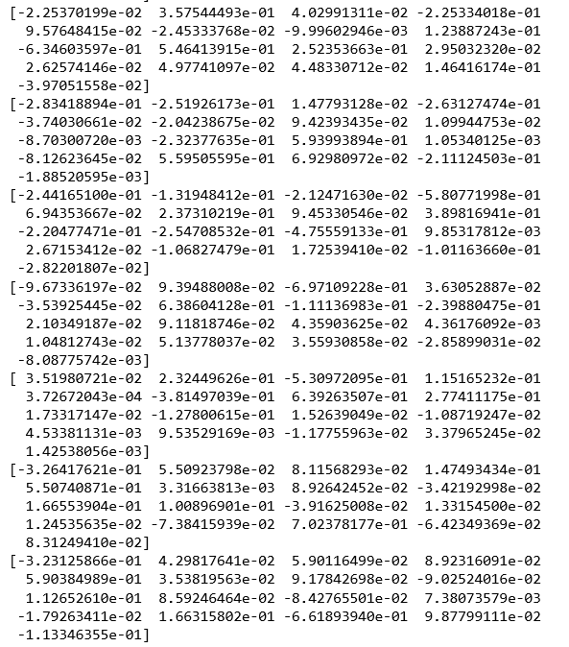

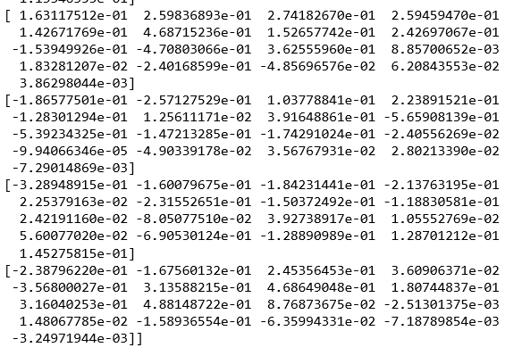

***2.6) Write the explicit form of the first PC (in terms of Eigen Vectors).***

PCA technique is drawing straight, explanatory lines through data.Which covers Maximum variance.

Each straight line represents a “principal component,” or a relationship between an independent and dependent variable. While there are as many principal components as there are dimensions in the data, PCA’s role is to prioritize them.

The first principal component bisects a scatterplot with a straight line in a way that explains the most variance; that is, it follows the longest dimension of the data. (This happens to coincide with the least error, as expressed by the red lines…)

Second component tries to fix the error of First Component, then Third willl try to fix errors caused by First and second Principal Component.It just goes on.

Eigen value is giving Strength/Magnitude of Line while Eigen vector gives us Direction. Eigen vector Represents Principal Component.

So General form of Conversion is

Current value of Covariance Matrix * Corresponding Eigen Vector Matrix = Eigen Valus * Target matrix produced by Mapping small projections on New line where most of variables Covered.

we can write Below equation based on this,

Covariance Matrix(A) * Eigen Vector of Matrix(u) = Scaled or Transformed version of Matrix(Which has same direction of Unscaled Matrix)

We can Write Above Equation in Simple Format as

##### *A * u = Lambda * u*[*¶*](http://localhost:8888/notebooks/Advanced%20Statistics%20Final%20Assignment%20Problem%202.ipynb#A-*-u-=-Lambda-*-u)

This 'Lambda' is scaled Factor Which is Nothing But Eigen value.

Basically lambda is Scaled multiplier of Matrix A by using Eigen Vector v, The Scale is Changed For the First Principal Component, [5.66219907] is Eigen Value and Eigen Vector is V[:,0]

In below module we can get Highest Cumulative variance as 33%, which shows First PC is Covering 33% data variance.

For First Principal Component let's find out Eigen Vector and its Eigen Value form that is lambda * Eigen Vector

For First Principal Component let's find out Eigen Vector and its Eigen Value form that is lambda * Eigen Vector

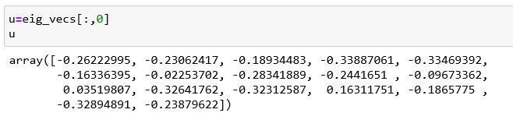

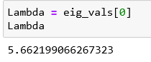

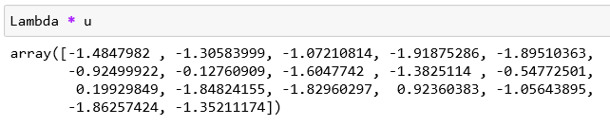

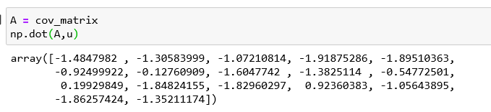

Above is the First Principal Component which is Scaled Version of Matrix applied to Eigen vector. We can see transformation as

***A.u = lambda * u***

***2.7) Discuss the cumulative values of the eigenvalues. How does it help you to decide on the optimum number of principal components? What do the eigenvectors indicate? Perform PCA and export the data of the Principal Component scores into a data frame***

The eigenvectors with the lowest eigenvalues bear the least information about the distribution of the data; those are the ones can be dropped.

Calculate Cumulative variance:

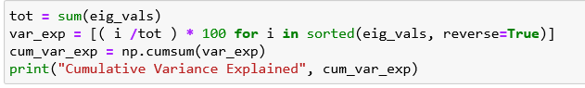



The Above shown cumulative values help us to Select optimum number of Principal components. The First Principal component covers 33.26% variance, If we select first Two as Principal components variance will be covered as 62%, If we select first 3 then 68.63% variance will be covered. Here we will select 5 pricipal components, so that it will cover 80% data.

***Data of the Principal Component scores into a data frame.***

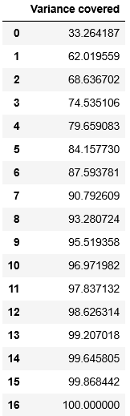

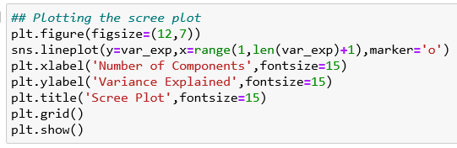

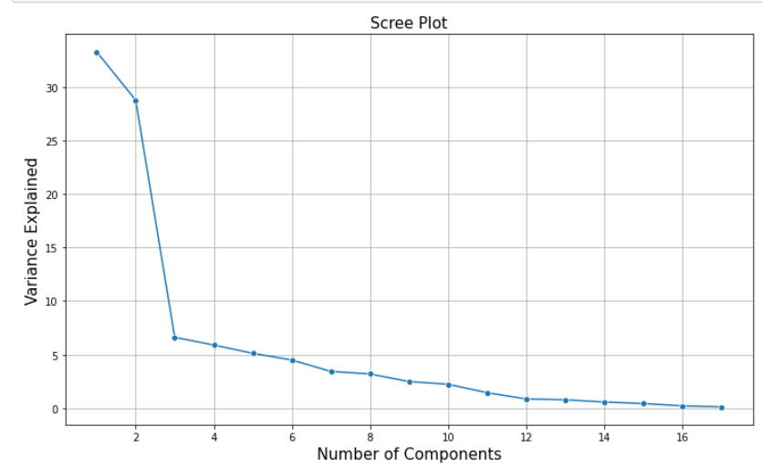

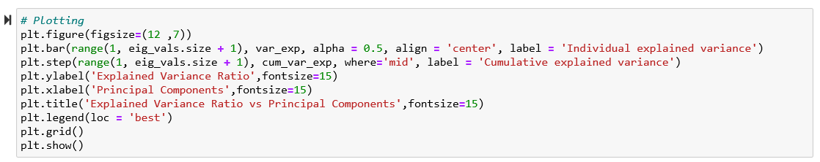

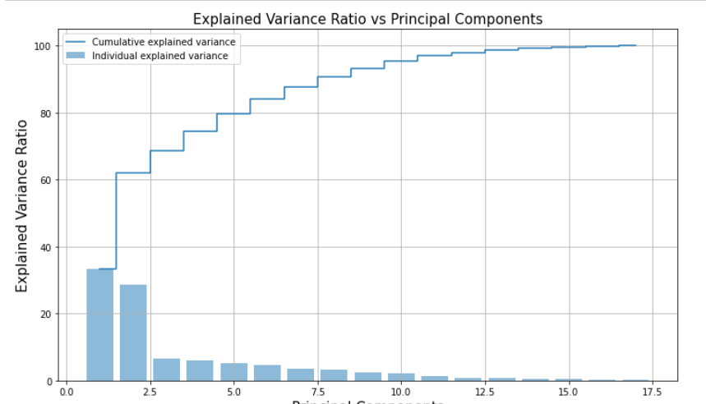

***PCAMethod 2***

Use PCA from sklearn's decomposition class and find Principal Components

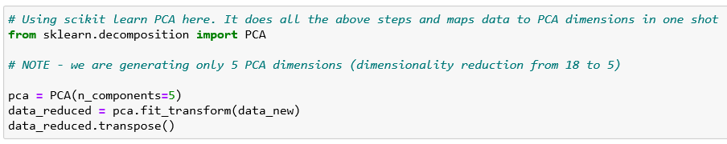

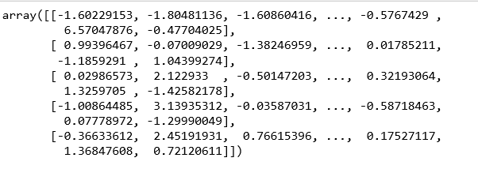

**Pca_components:**

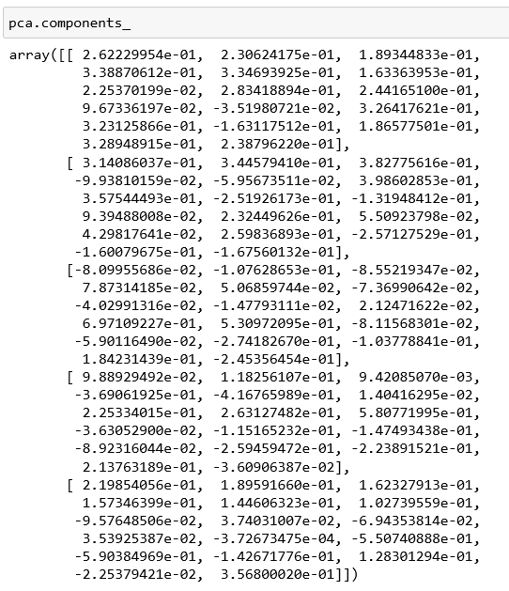

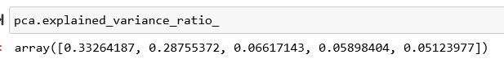

**cumulative sum of variance explained with 5 features:**

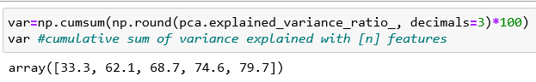

Lets plot a graph,”Cumulative explained variance Vs Number of features”

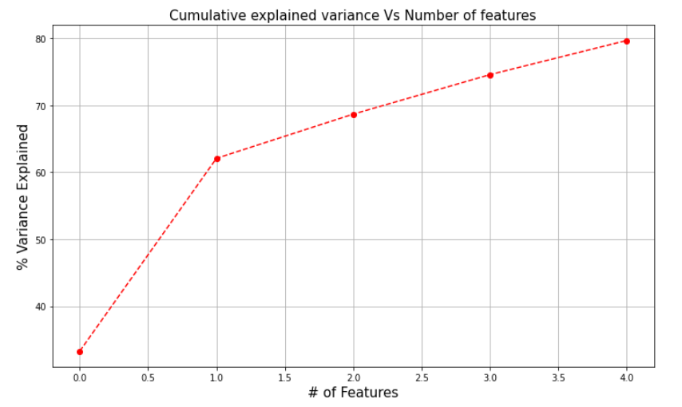

The plot above clearly shows that maximum variance (somewhere around 33.3%) can be explained by the first principal component alone. The second,third,fourth and fifth principal component share almost less amount of information.Comparatively 6th onwards components share less amount of information as compared to the rest of the Principal components.But those information cannot be ignored since they both contribute almost 21% of the data.We are covering 80% variance by considering 5 features.

The eigenvectors (principal components) determine the directions of the new feature space, and the eigenvalues determine their magnitude.

***Correlation between components and features***

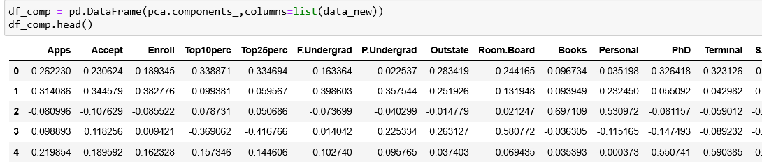

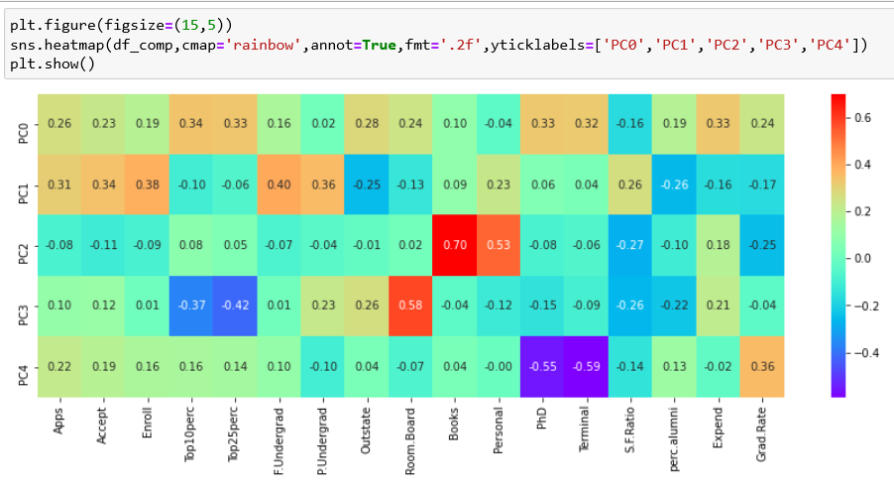

***2.8) Mention the business implication of using the Principal Component Analysis for this case study***

This heatmap and the color bar basically represent the correlation between the various feature and the principal component itself

1.PC0:Scholars : This Component Combines Top10% and Top25% Students in HSC, PhD candidates, Percentage of faculties with terminal degree--> It is Section where Scholars of College Comes.

2.PC1:Overall Admissions and Intake : No of Applications, No of Enrolled Students , No of Accepted Students, Full time Undergrad students, Part time Undergrad Students shows that they Mostly Contribute to Principal Component 1. we can name this Component as Overall Admissions and Intake as per our knowledge

3.PC2:Expenses: Personal and Books Expenses

4.PC3: Room and Boarding Expenses

5.PC4: Graduation Rate

So by using PCA we can Finally reduce 18 variables to 5 Principal Components.On basis of this we can give College Rankings,Acceptance Probability or Prediction of any random student will get admit or not from Particular college, College can decide its Fees on basis of This. College Can make Strategic Moves like Fees, How to attract more number of Scholars to College by providing them Scholarships, Fundings.

Whether to Increase Professors or Decrease it, Its impact on Admissions.

All this Kind Of Decision can be Made By Analysing data Ahead which is Produced by PCA.

Variables are Reduced, So now complex data is Looking Simpler, Without missing much Information